Baker Act Coordinator
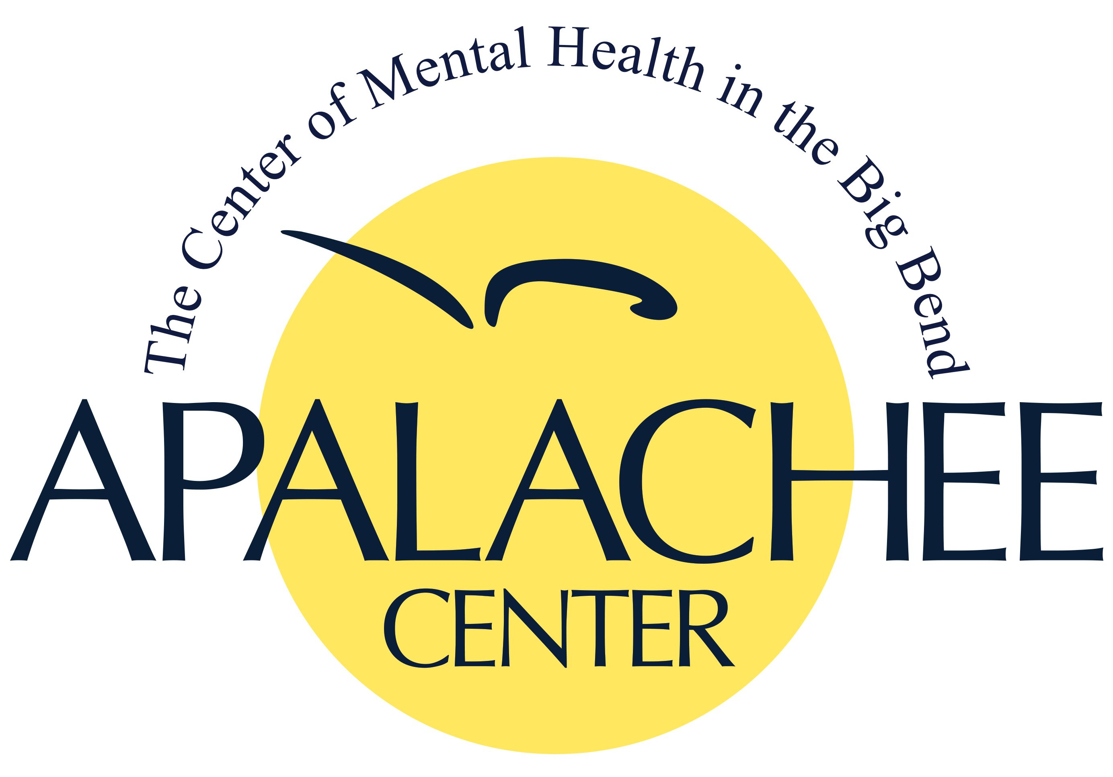
Apalachee Center, Inc. is best known for helping individuals and families of North Florida succeed in recovering from emotional, psychiatric, and substance abuse crises. Apalachee Center, Inc. provides comprehensive behavioral health services across 8 counties (Franklin, Gadsden, Jefferson, Leon, Liberty, Madison, Taylor, and Wakulla Counties).

Apalachee Center, Inc. offers competitive benefits for our full-time positions to include health, dental, vision, basic life insurance, long term disability, paid time off, and more.
Overview:
Serves as the Agency's Baker Act Coordinator and provides liaison services to staff, organizations and providers (e.g., Tallahassee Memorial Behavioral Healthcare (TMBHC), Florida State Hospital (FSH), court, Public Defender, etc.) on Baker Act-related matters in accordance with Florida Statutes/requirements.
Shift: Monday - Friday, 8:00am-5:00pm
Rate of Pay: Bachelor's Level $16.00-$18.00/hr.
Master's Level $20.00-$22.00/hr.
QUALIFICATIONS:
Education/Experience:
• Bachelor’s degree with a major in counseling, social work, psychology, criminal justice, nursing, rehabilitation, special education, health education, health science, or a related human services field.
• Master's degree preferred.
• One (1) year of related work experience in a mental health-related field required. Inpatient psychiatric experience preferred.
• Knowledge of the Criminal Justice system preferred.
Licensure or Certification:
Must maintain current CPR, CPI and First Aid certifications.
Must possess a current, valid driver’s license with no more than 6 points over 3 years and maintain Center authorization as a designated auto driver.

