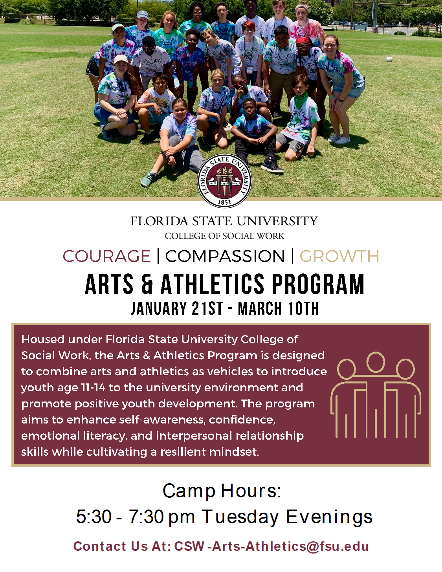

Hello Parents and Guardians,

We are excited that you are interested in The Florida State University College of Social Work Arts & Athletics Program!
My name is Sabrina Sprott and I am the 2020 Camp Director. This is my third year with the program and I could not be more thrilled to share the Seminole Spirit with your children. On behalf of the Arts & Athletics staff, we want to provide a detailed overview of the camp including expectations and program content.
The Arts & Athletics Camp introduces youth ages 11-14 to the university environment and works to promote positive youth development. The program aims to enhance self-awareness, confidence, emotional literacy, and interpersonal relationship skills while cultivating a resilient mindset.
We provide campers with an evening snack. If your child has any dietary preferences or food restrictions, please indicate them in the application. We will make accommodations to the best of our ability.
We ask that all campers come dressed comfortably, as some sessions involve athletic activities. Please ensure your child wears closed toe shoes, and clothing appropriate for outdoor activity. Please no spaghetti straps, tank tops with oversized armholes, short shorts, or extremely oversized clothing. We also suggest campers bring an umbrella and/or a poncho and a reusable water bottle.
Additionally, camp has a strict no phone policy. Campers may not use their phone at any time during camp. If you need to reach your child, you may contact the Program Director or Camp Director to facilitate contact.
Please complete all forms in the packet. Incomplete packets will not be considered. A checklist is provided at the end of the packet for your convenience. Thank you for your interest and consideration!

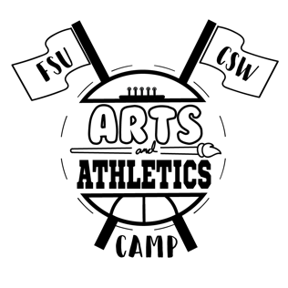

Best,
Sabrina Sprott, BSW
2020 Arts & Athletics Camp Director
csw-arts-athletics@fsu.edu

Florida State University College of Social Work
2019 Arts and Athletics Camp
Camper Application
Applications due December 18, 2019
Email application to: Sabrina Sprott at csw-arts-athletics@fsu.edu
Mail application to: FSU College of Social Work, c/o Shalay Jackson, 296 Champions Way,
PO Box 3062570, Tallahassee, FL 32306 -2570

Student Data

Name____________________________________________________________________ Gender: _____________
First Middle Initial Last

Birthdate:_______________/________________/_______________ Age:____________ Grade Entering:______________
Month Day Year

School: ________________________________________________________________________________________________

Race/Ethnicity: ______ Black/African-American _______White _______Hispanic/Latino _____Asian-American
______ Native American ______ Multiracial Other: ___________________________

Mailing Address: ________________________________________________________________________________________________
Street

___________________________________________________________________________________________________
City State Zip Code

Parent/Guardian Data

Parent/Guardian #1:

___________________________________________
Name
___________________________________________
Email (must be valid as this is the primary form of communication

___________________________________________
Best Contact Number
Parent/Guardian #2:

___________________________________________
Name
___________________________________________
Email (must be valid as this is the primary form of communication

__________________________________________
Best Contact Number

In Case of Emergency

Contact: ______________________________________________________________________________________________________
Name

______________________________________________________________________________________________________
Relationship and Contact Number

Student Health

Does your student have any special needs (food allergies, medical needs, etc.) camp staff should be aware of?
__________ YES ____________ NO
(Note: This information is not taken into consideration in the camper selection process. This information is used to adequately prepare to meet the needs of your child.)
If YES, please describe:
_______________________________________________________________________________________________________
_______________________________________________________________________________________________________
_______________________________________________________________________________________________________
_______________________________________________________________________________________________________

Does your student have any medications he/she must take regularly? _____________ YES __________NO
If YES, please describe:
_______________________________________________________________________________________________________
_______________________________________________________________________________________________________
_______________________________________________________________________________________________________

I, ______________________________, hereby affirm all student health information is accurate and fully disclosed.
Parent/Guardian
________________________________________________________________ _________________
Signature Date

Other
This program has a strict no phone policy. If you need reach your child, you may contact the Program Director or Camp Director to facilitate contact. Please initial to indicate understanding and acceptance. _____________

Program hours are from 5:30 p.m. – 7:30 p.m. Children must be picked up no later than 7:30 p.m. each day. Please initial to indicate understanding and acceptance. ________________

Camper T-shirt Size (please check one):
______ Adult Small _______ Adult Medium

______Adult Large _______Adult X-Large

Short Essay Questions (to be completed by prospective camper)

What is your best quality?
_____________________________________________________________________________________________________________________________________________________________________________________________________________________________________________________________________________________________________________________

Why do you want to participate in the arts and athletics program?
_______________________________________________________________________________________________________________________________________________________________________________________________________________________________________________________________________________________________________________________________________________________________________________________________________________________________________________________________________________________________________________________________________________________________________________________________________________________________________________________________________________________________________________________________________________________________________________________________________________________________________________________________________________________________________________________________________________________________

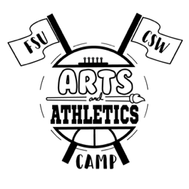
Florida State University

College of Social Work

2020 Arts & Athletics Program

STATEMENT OF VOLUNTARY CONSENT

In consideration of my minor child’s participation in the 2020 Florida State University College of Social Work Arts & Athletics Program (hereafter referred to as the Program) and having actual knowledge and appreciation of and those risks involved in the Program, I voluntarily consent to my minor child’s participation in the Program and assume the risks arising therefrom.
In consenting to involvement, I also acknowledge that I have been informed regarding activity, skills, risks, and specific guidelines associated with participation in the Program, as outlined in the following summary.

NOTICE TO THE MINOR CHILD’S NATURAL GUARDIAN
READ THIS FORM COMPLETELY AND CAREFULLY. YOU ARE AGREEING TO LET
YOUR MINOR CHILD ENGAGE IN A POTENTIALLY DANGEROUS ACTIVITY. YOU
ARE AGREEING THAT, EVEN IF THE FSU BOARD OF TRUSTEES OR ITS AGENTS
(“FSU”) USE REASONABLE CARE IN PROVIDING THIS ACTIVITY, THERE IS A
CHANCE YOUR CHILD MAY BE SERIOUSLY INJURED OR KILLED BY
PARTICIPATING IN THIS ACTIVITY BECAUSE THERE ARE CERTAIN DANGERS
INHERENT IN THE ACTIVITY WHICH CANNOT BE AVOIDED OR ELIMINATED. BY
SIGNING THIS FORM, YOU ARE GIVING UP YOUR CHILD’S RIGHT AND YOUR
RIGHT TO RECOVER FROM FSU IN A LAWSUIT FOR ANY PERSONAL INJURY,
INCLUDING DEATH, TO YOUR CHILD OR ANY PROPERTY DAMAGE THAT RESULTS
FROM THE RISKS THAT ARE A NATURAL PART OF THE ACTIVITY. YOU HAVE THE RIGHT TO REFUSE TO SIGN THIS FORM, AND FSU HAS THE RIGHT TO REFUSE TO LET YOUR CHILD PARTICIPATE IF YOU DO NOT SIGN THIS FORM.
I HEREBY CONSENT, declare and represent, as evidenced by my signature below, that I am on notice that The Florida State University has no insurance to cover me, or my child in the event that the undersigned participating child is under eighteen years of age, in the event of injury or death and I specifically release and hold harmless Florida State University, Florida State University Board of Trustees, its employees, and personnel from any and all liability connected with this activity and assume all risks, liabilities and responsibilities for any and all accidents, injury or property loss arising therefrom, and it has been strongly recommended to me that I obtain medical insurance prior to the aforementioned activities.

Finally, I hereby declare and represent that in making, executing, and tendering this Statement of Voluntary Consent, I fully understand and acknowledge that I am relying wholly upon my own judgment, belief and knowledge of the circumstances involved in my minor child’s participation in the described activity, and that I have read this statement, understood its contents and executed it of my free will and choice.

I acknowledge on behalf of my minor child that my minor child is in good physical condition and does not have a problem, which would preclude my child’s participation in the activities as a consequence of any and all injury, loss or damage, directly or indirectly sustained by my child through participation in the aforementioned activity.
Participant Name:

Parent/Guardian Name  (if participant is under age18) | Signature | Date

Notary Signature Date
PHOTO/MEDIA RELEASE

I do not grant Florida State University’s CSW Arts & Athletics Program and persons acting for, or through them, the right to use, reproduce, assign and/or distribute photographs, films, videotapes, and sound recordings of me and/or my minor child for use in materials they may create.
do

Signature Date

Application Checklist

☐ Completed Camper Application

☐ Completed Statement of Voluntary Consent

☐ Completed Photo/Media Consent

☐ Submit Application

Applications due December 6th, 2019. Late applications will not be considered.
Applicants will be notified via email of their acceptance.

Submit via email to:
Sabrina Sprott at csw-arts-athletics@fsu.edu
Submit application via mail to:
FSU College of Social Work
c/o Shalay Jackson
296 Champions Way, PO Box 3062570
Tallahassee, FL 32306 -2570

